**Swagger UI for APi**

Install SwatchBuckle package



Create Controllers and Models for the Api in Visual Studio

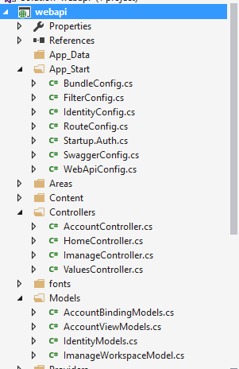

Model class

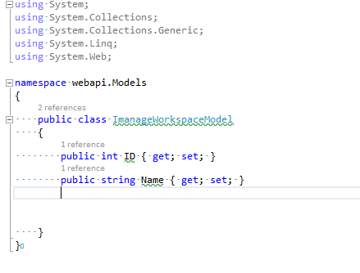

Controller and Methods

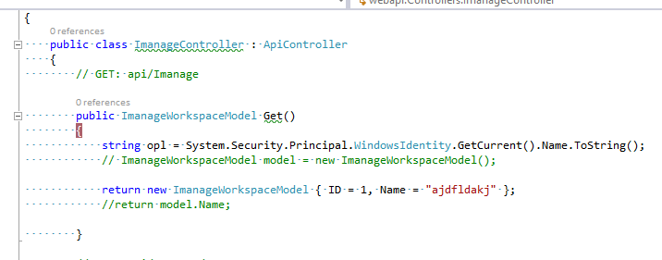

Run the Solution

Initial Homepage

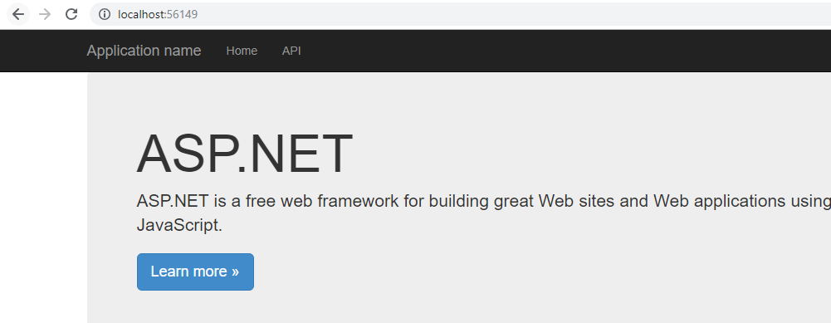

Append Swagger to the url



Swagger Interface

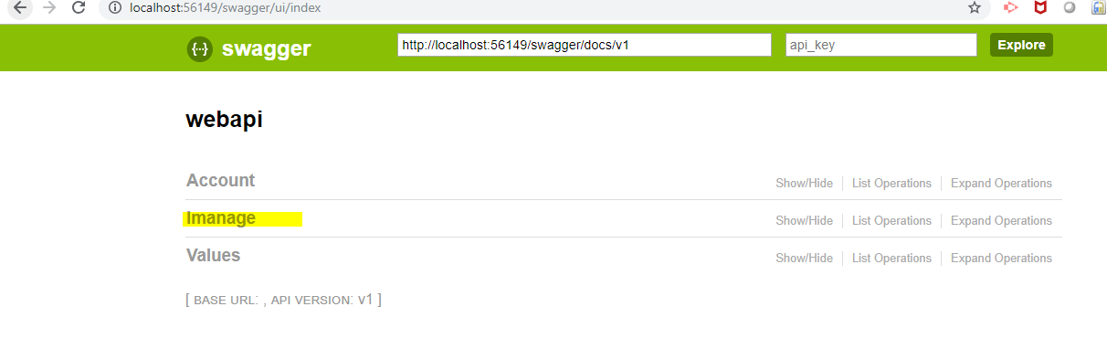

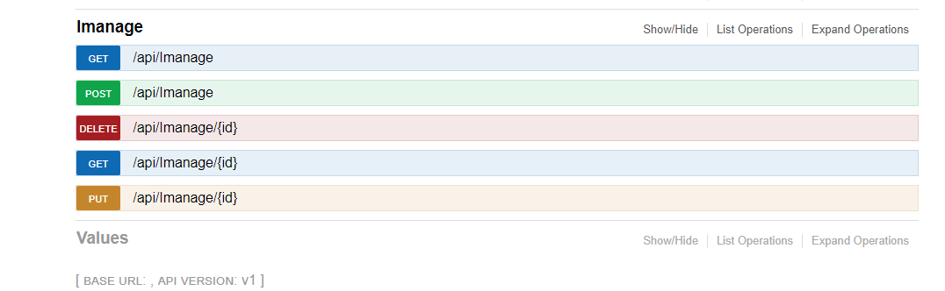

Click on Get Method

You will see the documentation

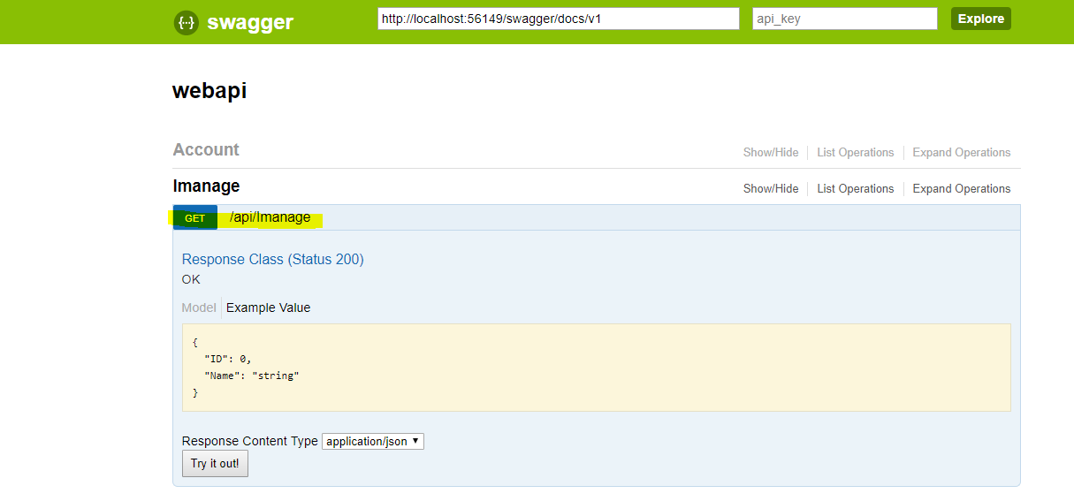

Click on try out option

You will see the response

